
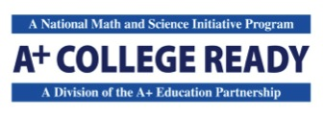

Parent Consent, Agreement, and Release

This completed form must be kept on file at the school. This form is valid for the life of the school’s partnership with A+ College Ready.

Name of School

Name of Student (printed)

Parent Consent, Agreement, and Release:

I recognize that my student’s school receives support from the Alabama State Department of Education (ALSDE) through A+ College Ready, a nonprofit educational organization, to establish and build the PreAP/Honors and AP courses available to my student. I understand that this support provides training, stipends, and study sessions for teachers and students in AP courses in math, science, and English. I recognize that ALSDE/A+ College Ready AP Initiative uses student demographic and achievement data to assess the effectiveness of the program and to determine stipend payments for teachers and students.

I hereby consent to the disclosure of my student’s school data to ALSDE/A+ College Ready, upon its request, and hereby grant ALSDE/A+ College Ready the right to review all records including but not limited to, my student’s SSID and/or State ID number, records relating to enrollment in PreAP and AP courses, academic standing, age, gender, grade level, achievement results, and free/reduced lunch qualifying status. All data will be managed consistently with the Family Educational Rights and Privacy Act (FERPA) and Alabama State Law regarding the confidentiality of data.

I have read this carefully and know it contains a release.
(Only one parent/guardian signature is required.)

Name of Parent/Guardian (printed) Signature of Parent/Guardian Date

